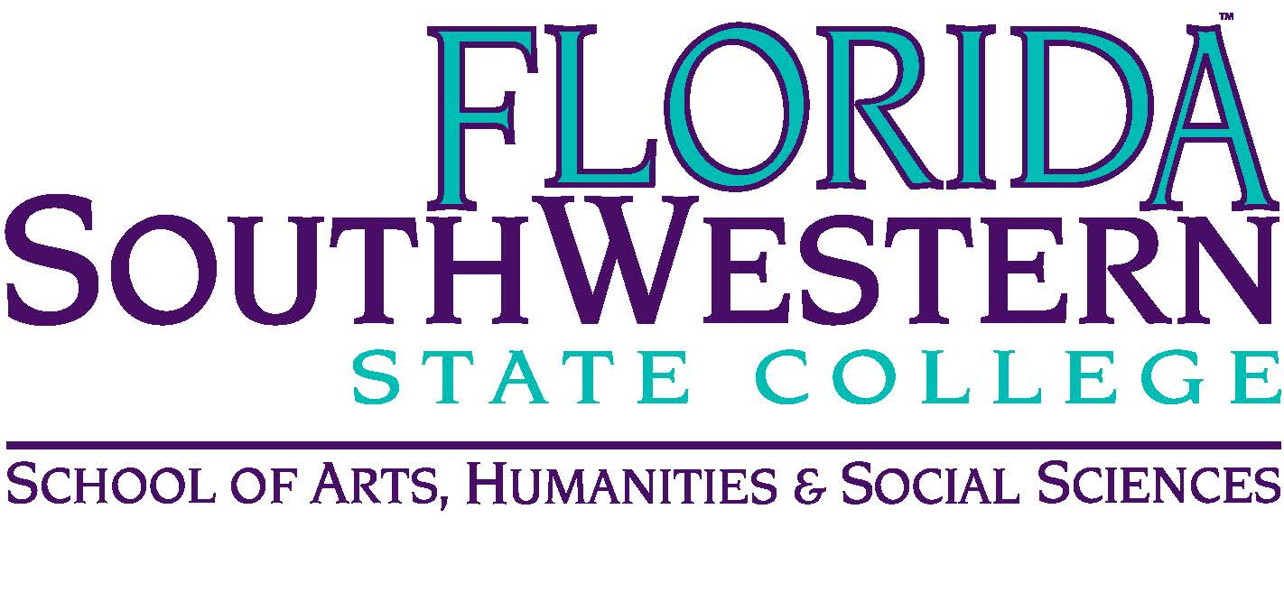
Department of Humanities and Fine Arts
Meeting Minutes
Date: January 7, 2021 - 10:00 a.m.
Location: Virtual/Online (Zoom)
Chair: Dana Roes
Minutes: Michael McGowan

 | Present | Absent | Excused
Brown | X
Chase, S | X
Chase, W | X
Doiron | X
Hoover | X
Lublink |  |  | X
McGowan | X
Mompoint | X
Pritchett | X
Roes | X
Sutter | X
Smith | X
Swanson | X
Molloy | X
Krupinski | X
Wurst | X
Harrington | X
Chowdhury | X
Gresens | X
Guests | Dr. Teed, Dr. Page

- Opening
  - Call to Order: 10:00 a.m.
  - Attendance taken
  - Minutes from November 2020 approved
- Announcements:
  - Syllabi issues:
    - We can ask students in our syllabi to turn on their cameras.
    - PPE can be put in the syllabus, too.
    - Zoom etiquette policies are also okay on syllabi.
  - Deadlines
    - FEE Grant: 1/15/21
    - Add/Drop period: 1/13/21
    - Attendance verification: 1/14/21
  - Dale Hoover has cancer and is undergoing chemotherapy. He’s not coming back this spring, and we’re brainstorming gifts from the department. One option: Gift basket with Amazon gift card

- Information Items:
  - Assessment update (Elijah): syllapalooza is underway. We’re talking to Chairs and Deans about updating learning outcomes. Reread the CREATIVE acronym and identify which apply to that course. They’re dealing with Gen Ed assignments from the fall right now. Deadline: April 9th our dept. meeting rolls into our assessment review.
    - Send an email to Elijah in the next week or two for revisiting learning outcomes and how to assess it
    - Email Monica with suggestions on speaking up for a Gen Ed course.
  - See Russell for Mindfulness training and ask students to get involved
  - Dr. Teed: Portfolium is where we hold onto documents, but Dr. Teed wants it sent to her and Wendie, too. She wanted to congratulate us for getting certified in online education programs. Scheduling for Summer and Fall 2021 is coming soon. Think about which modalities we want to teach using, because Dr. Page is sending out load sheets soon. Deadlines:
    - Form 1 is due on February 12th
    - Form 3 is due in April
  - Professional Development Update (Sarah Lublink): For the next three PD Fridays: in the morning (8:30), we have a “pedagogy of kindness” specialist.
  - Compliance Training: Update the Title IX training online, especially with SACS coming soon.
  - Len Olsen: we should choose our own books (the department agrees, but we’re fighting with textbook guidelines coming down from the state). There may be an opening now that wasn’t there a year or two ago.

- Discussion:
  - Transdisciplinary Incentives:
    - Ben and Rebecca want to design capstone classes in a variety of disciplines.
    - The Honors program is looking for developing a seminar that is team-taught and transdisciplinary. Some are looking to create documentaries, so they may need Ryan and Steve’s help. Example: Don Ransford wants to collaborate with the arts, so let him know if you’re interested.
    - We should be more vocal about the interesting classes we offer (and stay on top of the way our classes are listed in the registration system; Russell suggested a yearly standing meeting to address the issues. We’d prefer to have our own advisors.)
  - Pathways: we’ll talk about this next time we meet.

- Next Meeting: 2/12/21 at 10:00 a.m.

